**Aim: To interface Seven Segment Display (SSD) with Arduino and write a program to print numbers from 0 to 9 on SSD**

**THEORY:**

**Seven Segment Displays:**

Seven segment displays are the output display device that provides a way to display information in the form of image or text or decimal numbers which is an alternative to the more complex dot matrix displays. It is widely used in digital clocks, basic calculators, electronic meters, and other electronic devices that display numerical information. It consists of seven segments of light emitting diodes (LEDs) which are assembled like numerical 8.

**Working of Seven Segment Displays:**

The number 8 is displayed when the power is given to all the segments and if you disconnect the power for ‘g’, then it displays number 0. In a seven segment display, power (or voltage) at different pins can be applied at the same time, so we can form combinations of display numerical from 0 to 9. Since seven segment displays cannot form alphabet like X and Z, so it cannot be used for alphabet and it can be used only for displaying decimal numerical magnitudes. However, seven segment displays can form alphabets A, B, C, D, E, and F, so they can also use for representing hexadecimal digits.

**CIRCUIT DIAGRAM:**

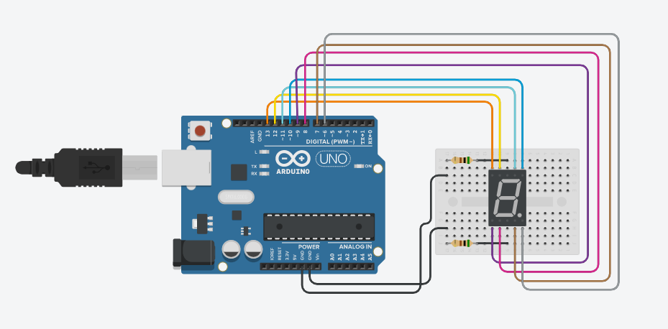

**SOURCE CODE:**

unsigned const int A = 13;

unsigned const int B = 12;

unsigned const int C = 11;

unsigned const int D = 10;

unsigned const int E = 9;

unsigned const int F = 8;

unsigned const int G = 7;

unsigned const int H = 6;

void setup(void)

{

pinMode(A, OUTPUT);

pinMode(B, OUTPUT);

pinMode(C, OUTPUT);

pinMode(D, OUTPUT);

pinMode(E, OUTPUT);

pinMode(F, OUTPUT);

pinMode(G, OUTPUT);

pinMode(H, OUTPUT);

}

void zero(void) {

digitalWrite(A, LOW);

digitalWrite(B, HIGH);

digitalWrite(C, HIGH);

digitalWrite(D, HIGH);

digitalWrite(E, HIGH);

digitalWrite(F, HIGH);

digitalWrite(G, HIGH);

digitalWrite(H, LOW);

}

void one(void) {

digitalWrite(A, LOW);

digitalWrite(B, LOW);

digitalWrite(C, LOW);

digitalWrite(D, HIGH);

digitalWrite(E, LOW);

digitalWrite(F, LOW);

digitalWrite(G, HIGH);

digitalWrite(H, LOW);

}

void two(void) {

digitalWrite(A, HIGH);

digitalWrite(B, LOW);

digitalWrite(C, HIGH);

digitalWrite(D, HIGH);

digitalWrite(E, HIGH);

digitalWrite(F, HIGH);

digitalWrite(G, LOW);

digitalWrite(H, LOW);

}

void three(void) {

digitalWrite(A, HIGH);

digitalWrite(B, LOW);

digitalWrite(C, HIGH);

digitalWrite(D, HIGH);

digitalWrite(E, LOW);

digitalWrite(F, HIGH);

digitalWrite(G, HIGH);

digitalWrite(H, LOW);

}

void four(void) {

digitalWrite(A, HIGH);

digitalWrite(B, HIGH);

digitalWrite(C, LOW);

digitalWrite(D, HIGH);

digitalWrite(E, LOW);

digitalWrite(F, LOW);

digitalWrite(G, HIGH);

digitalWrite(H, LOW);

}

void five(void) {

digitalWrite(A, HIGH);

digitalWrite(B, HIGH);

digitalWrite(C, HIGH);

digitalWrite(D, LOW);

digitalWrite(E, LOW);

digitalWrite(F, HIGH);

digitalWrite(G, HIGH);

digitalWrite(H, LOW);

}

void six(void) {

digitalWrite(A, HIGH);

digitalWrite(B, HIGH);

digitalWrite(C, HIGH);

digitalWrite(D, LOW);

digitalWrite(E, HIGH);

digitalWrite(F, HIGH);

digitalWrite(G, HIGH);

digitalWrite(H, LOW);

}

void seven(void) {

digitalWrite(A, LOW);

digitalWrite(B, LOW);

digitalWrite(C, HIGH);

digitalWrite(D, HIGH);

digitalWrite(E, LOW);

digitalWrite(F, LOW);

digitalWrite(G, HIGH);

digitalWrite(H, LOW);

}

void eight(void) {

digitalWrite(A, HIGH);

digitalWrite(B, HIGH);

digitalWrite(C, HIGH);

digitalWrite(D, HIGH);

digitalWrite(E, HIGH);

digitalWrite(F, HIGH);

digitalWrite(G, HIGH);

digitalWrite(H, LOW);

}

void nine(void) {

digitalWrite(A, HIGH);

digitalWrite(B, HIGH);

digitalWrite(C, HIGH);

digitalWrite(D, HIGH);

digitalWrite(E, LOW);

digitalWrite(F, HIGH);

digitalWrite(G, HIGH);

digitalWrite(H, LOW);

}

void loop(void)

{

zero();

delay(1000);

one();

delay(1000);

two();

delay(1000);

three();

delay(1000);

four();

delay(1000);

five();

delay(1000);

six();

delay(1000);

seven();

delay(1000);

eight();

delay(1000);

nine();

delay(1000);

}

**OUTPUT:**

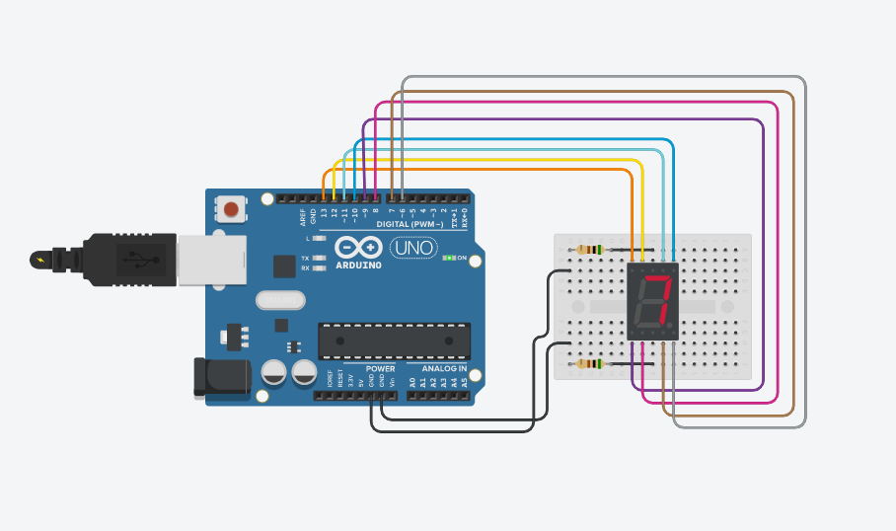

**CONCLUSION:**

Successfully interfaced Seven Segment Display (SSD) with Arduino & programed it to print numbers from 0 to 9 on SSD